**Task1:** Create two integer variables length and breadth and assign values then check if they are square values or rectangle values. ie: if both values are equal then it's square otherwise rectangle.

**Code:**

import "dart:io";

void main(){

 int length=25;

 int breadth=30;

 if(length==breadth){

print("These are square variables");

 }

 else{

  print("These are rectangle variable");}}

**Output:**

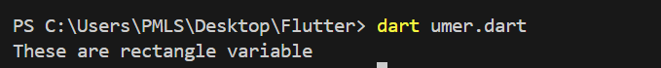

Task 2: Take two variables and store age then using if/else condition to determine oldest and youngest among them.

Code:

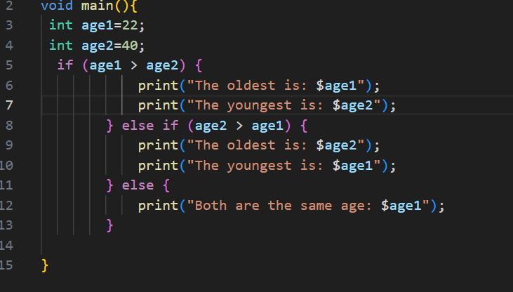

Output:

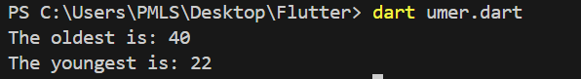

Task 3: A student will not be allowed to sit in exam if his/her attendance is less than 75%. Create integer variables and assign value: Number of classes held = 16, Number of classes attended = 10, and print percentage of class attended. Is student is allowed to sit in exam or not?

Code:

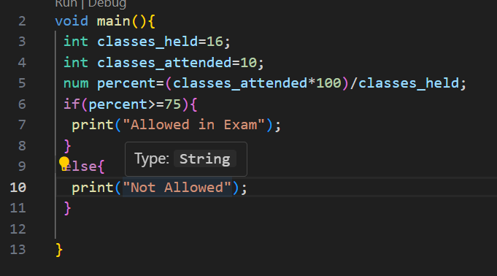

Output:



Task 4: Write a program to convert Celsius to Fahrenheit . i.e: Temperature in degrees Fahrenheit (°F) = (Temperature in degrees Celsius (°C) * 9/5) + 32

Code:

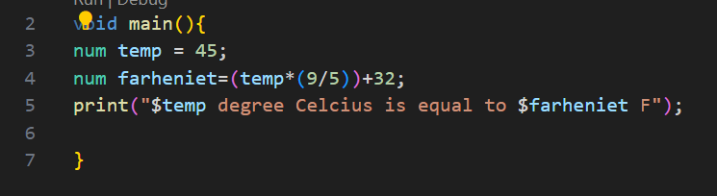

Output:



Task 5: Write a program to read temperature in centigrade and display a suitable message according to temperature: You have num variable temperature = 42; Now print the message according to temperature: temp < 0 then Freezing weather temp 0-10 then Very Cold weather temp 10-20 then Cold weather temp 20-30 then Normal in Temp temp 30-40 then Its Hot temp >=40 then Its Very Hot

Code:

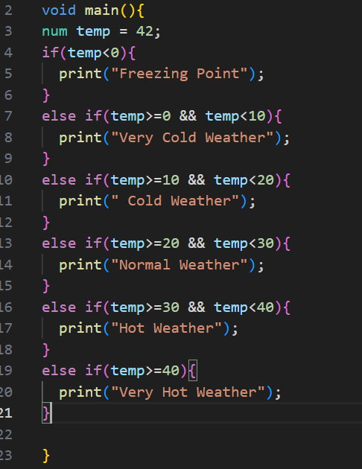

Output:



Task 6: Write a program to check whether an alphabet is a vowel or consonant.

Code:

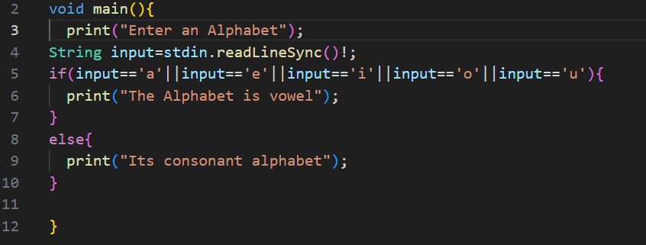

Output:

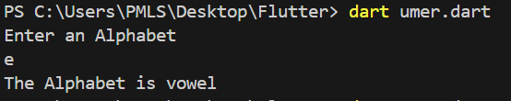

Task 7: Write a program to calculate root of any number. i.e: √y = y½.

Code:

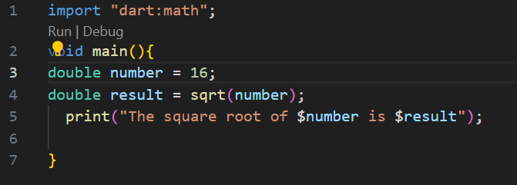

Output:

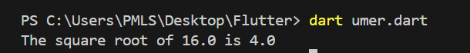

Task 8: : Create a marksheet using operators of at least 5 subjects and output should have Student Name, Student Roll Number, Class, Percentage, Grade Obtained etc. i.e: Percentage should be rounded upto 2 decimal places only.

Code:

import "dart:math";

void main(){

  String studentName = "Muhammad Umer";

  String rollNumber = "02-131222-031";

  String studentClass = "4th semester";

  int marksSubject1 = 85;

  int marksSubject2 = 78;

  int marksSubject3 = 92;

  int marksSubject4 = 74;

  int marksSubject5 = 88;

  int totalMarksObtained = marksSubject1 + marksSubject2 + marksSubject3 + marksSubject4 + marksSubject5;

  int totalMaximumMarks = 500;

  double percentage = (totalMarksObtained / totalMaximumMarks) * 100;

  String grade;

  if (percentage >= 90) {

    grade = "A+";

  } else if (percentage >= 80) {

    grade = "A";

  } else if (percentage >= 70) {

    grade = "B";

  } else if (percentage >= 60) {

    grade = "C";

  } else if (percentage >= 50) {

    grade = "D";

  } else {

    grade = "F";

  }

  print("---- Marksheet ----");

  print("Student Name: $studentName");

  print("Roll Number: $rollNumber");

  print("Class: $studentClass");

  print("Marks Obtained:");

  print("Subject 1: $marksSubject1");

  print("Subject 2: $marksSubject2");

  print("Subject 3: $marksSubject3");

  print("Subject 4: $marksSubject4");

  print("Subject 5: $marksSubject5");

  print("Total Marks Obtained: $totalMarksObtained out of $totalMaximumMarks");

  print("Percentage: ${percentage.toStringAsFixed(2)}%");

  print("Grade Obtained: $grade");

}

Output:

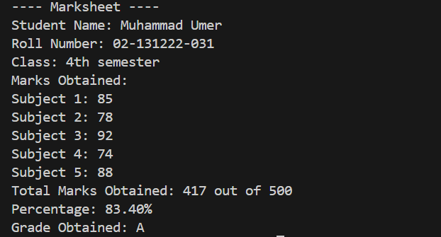

Task 9: Check if the number is even or odd, If number is even then check if this is divisible by 5 or not & if number is odd then check if this is divisible by 7 or not.

Code:

void main() {

  int number = 35;

  if (number % 2 == 0) {

    print("$number is even.");

    if (number % 5 == 0) {

      print("$number is divisible by 5.");

    } else {

      print("$number is not divisible by 5.");

    }

  } else {

    print("$number is odd.");

    if (number % 7 == 0) {

      print("$number is divisible by 7.");

    } else {

      print("$number is not divisible by 7.");

    }

  }

}

Output:

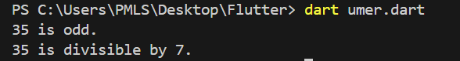

Task 10: Write a program that takes three numbers from the user and prints the greatest number & lowest number.

Code:

import 'dart:io';

void main() {

  print("Enter the first number:");

  int number1 = int.parse(stdin.readLineSync()!);

  print("Enter the second number:");

  int number2 = int.parse(stdin.readLineSync()!);

  print("Enter the third number:");

  int number3 = int.parse(stdin.readLineSync()!);

  int greatest = number1;

  if (number2 > greatest) {

    greatest = number2;

  }

  if (number3 > greatest) {

    greatest = number3;

  }

  int lowest = number1;

  if (number2 < lowest) {

    lowest = number2;

  }

  if (number3 < lowest) {

    lowest = number3;

  }

  print("The greatest number is: $greatest");

  print("The lowest number is: $lowest");

}

Output:

